Lab 08
Two-Dimensional Arrays in C++

Objective
The objective of this lab is to understand and implement two-dimensional arrays in C++, including their declaration, initialization, and traversal using loops.
Introduction
A two-dimensional array is a collection of elements arranged in rows and columns, similar to a table or matrix. It allows storing multiple values in a structured format and is commonly used in applications such as matrices, grids, and tables.

Theory
A two-dimensional array in C++ is declared as:

Example

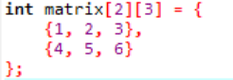

Key Points
- It consists of rows and columns
- Indexing starts from 0
- Access element using:
array[row][column]
- Nested loops are used to traverse the array

Algorithm:
- Start
- Declare a 2D array
- Input values (optional)
- Use nested loops to access elements
- Display the array
- End
Program:

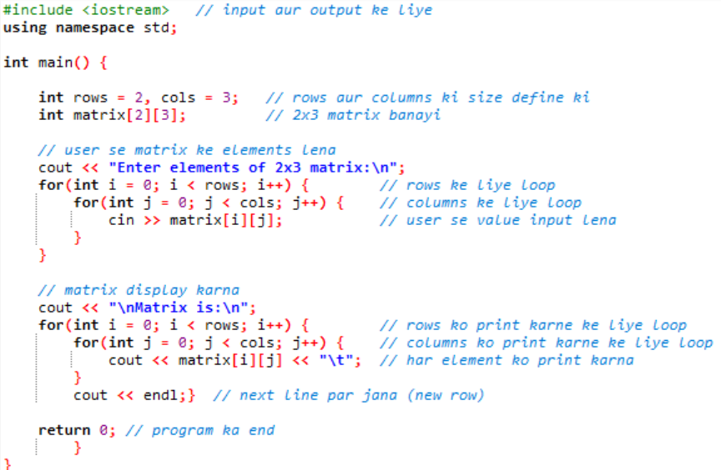

Output:

Enter elements of 2x3 matrix:
1 2 3
4 5 6
Matrix is:
1 2 3
4 5 6
Lab Tasks
Task 01:
Two-Dimensional Array Declaration and Initialization
• Declare a 2D integer array called ”matrix” with dimensions 3x3.
• Initialize the array with values 1, 2, 3, 4, 5, 6, 7, 8, and 9.
• Display the values of the array elements using nested loops.
Code:
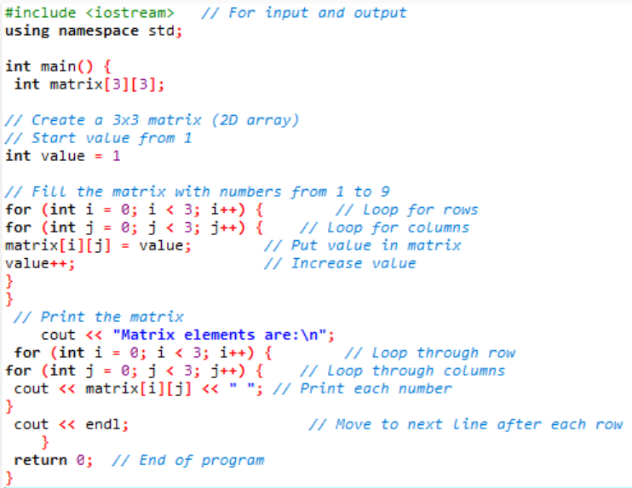

Task 02:
Sum of Rows and Columns in a Two-Dimensional Array
• Declare and initialize a 3x3 integer array with random values.
• Calculate and display the sum of each row and each column separately.
• Display the total sum of all the elements in the array.

Code:

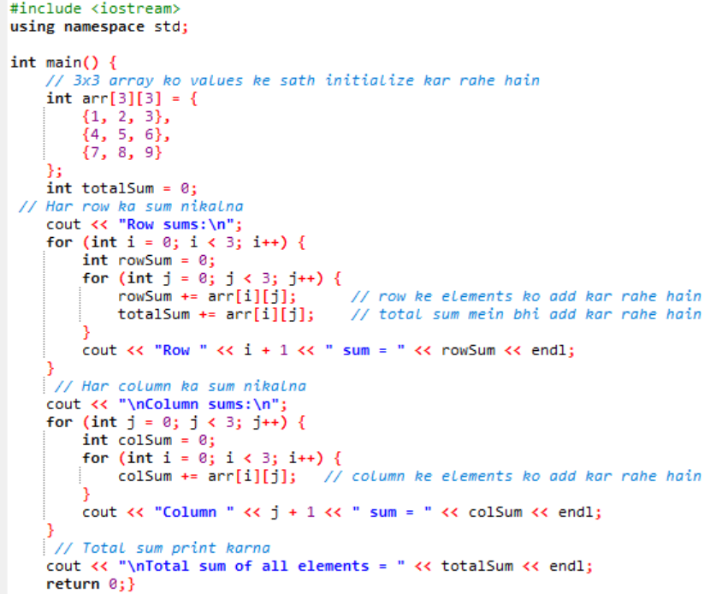

Task 03:
Finding the Maximum Value in a Two-Dimensional Array
• Declare and initialize a 4x4 integer array with random values
• Find and display the maximum value in the array.

Code:
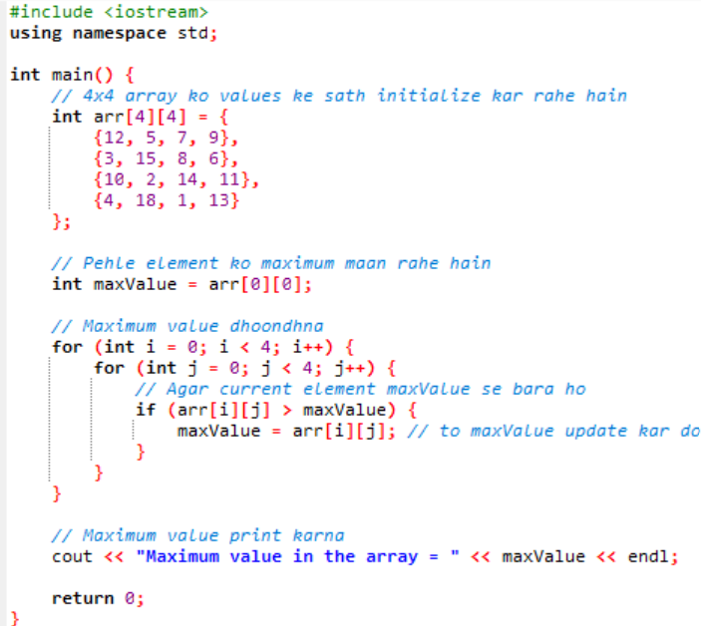

Conclusion:
In this lab, we learned how to declare, initialize, and manipulate two-dimensional arrays in C++. We also practiced using nested loops to input and display matrix elements. This concept is essential for handling structured data like tables and matrices in programming.

